**Patient Risk Profiling**

**An Engineering App in Community Service**

**Phase-II Report**

***Submitted by***

|  |  |  |
| --- | --- | --- |
| **Sl. No.** | **Register Number** | **Name** |
| 1 | 21BCY10019 | Siddarth Dayal |
| 2 | 21BAC10005 | Ashutosh Kumar Srivastava |
| 3 | 21BCG10100 | Chetan Khoche |
| 4 | 21BCE11407 | Devansh Trivedi |
| 5 | 21BCE11559 | GPV Mruthunjai |
| 6 | 21BCE11342 | Rishabh Pradhaan |
| 7 | 21BCG10072 | Rishikesh M |
| 8  9 | 21BCG10075  21BCE11334 | Ankit Sankar  Yashsh Sujitkumar Randive |

***In partial fulfilment of the requirements for the degree of***

***Bachelor of Technology***



**VIT Bhopal University  
Bhopal  
Madhya Pradesh**

**March 2024**

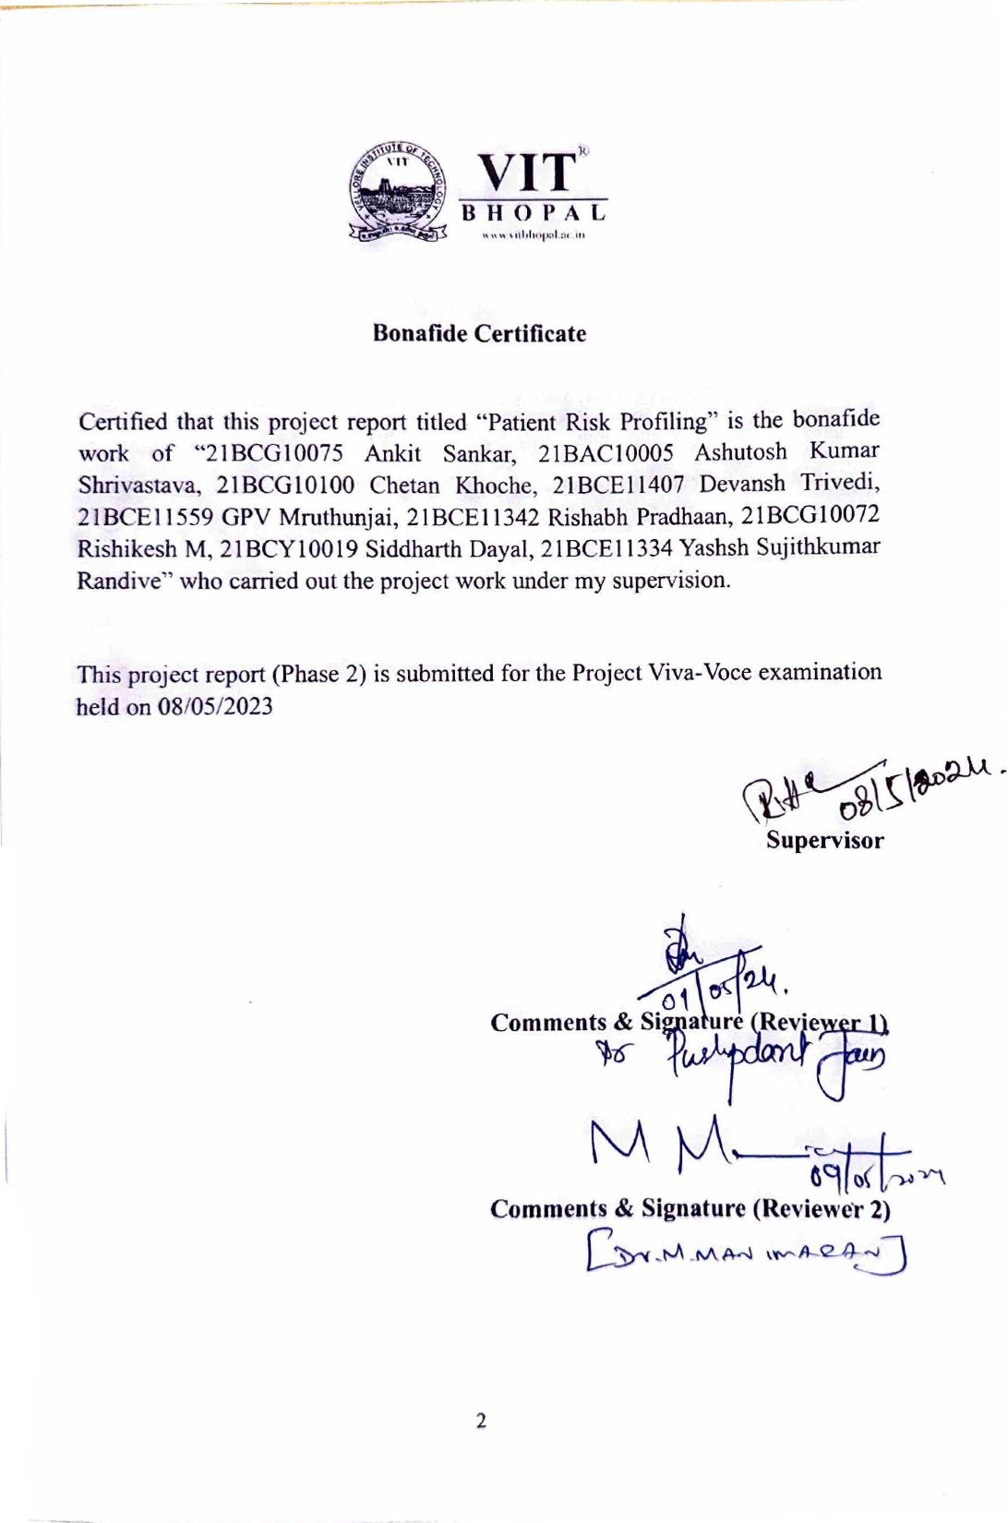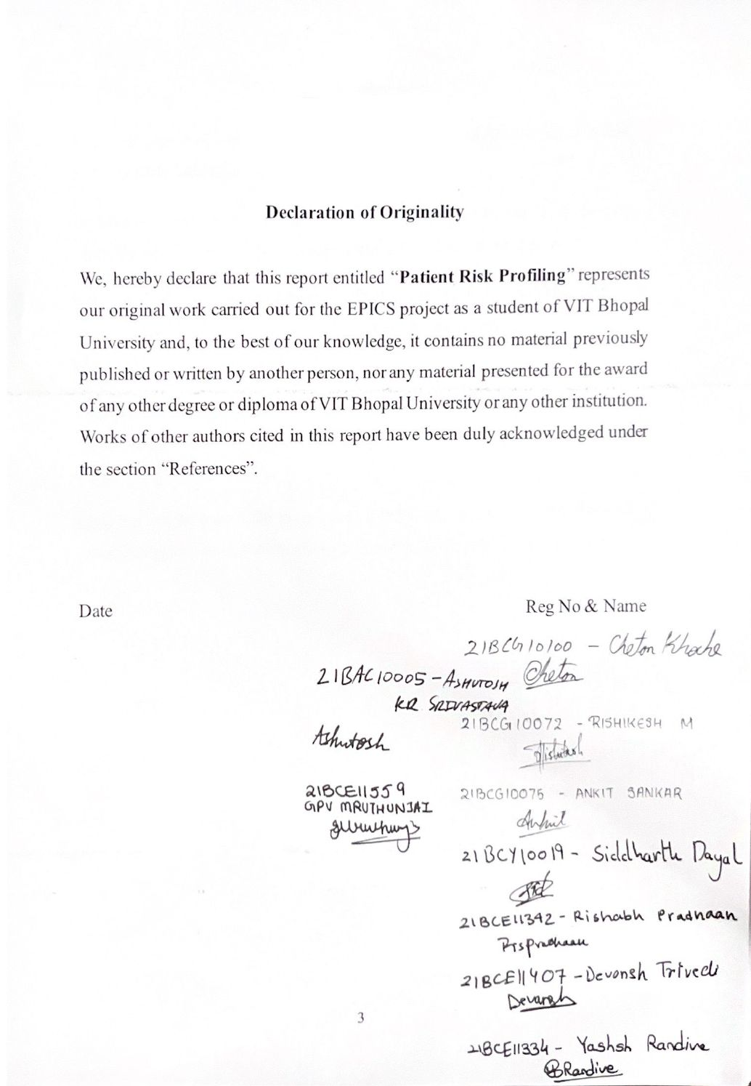

**Bonafide Certificate**

Certified that this project report titled “Patient Risk Profiling” is the bonafide work of “21BCG10075 Ankit Sankar, 21BAC10005 Ashutosh Kumar Shrivastava, 21BCG10100 Chetan Khoche, 21BCE11407 Devansh Trivedi, 21BCE11559 GPV Mruthunjai, 21BCE11342 Rishabh Pradhaan, 21BCG10072 Rishikesh M, 21BCY10019 Siddharth Dayal, 21BCE11334 Yashsh Sujithkumar Randive” who carried out the project work under my supervision.

This project report (Phase 2) is submitted for the Project Viva-Voce examination held on 08/05/2023

**Supervisor**

**Comments & Signature (Reviewer 1)**

**Comments & Signature (Reviewer 2)**



**Declaration of Originality**

We, hereby declare that this report entitled “**Patient Risk Profiling**” represents our original work carried out for the EPICS project as a student of VIT Bhopal University and, to the best of our knowledge, it contains no material previously published or written by another person, nor any material presented for the award of any other degree or diploma of VIT Bhopal University or any other institution. Works of other authors cited in this report have been duly acknowledged under the section “References”.

Date Reg No & Name

09/04/2024

**Acknowledgement**

First and foremost, I would like to thank the Lord Almighty for His presence and immense blessings throughout the project work.

I wish to express my heartfelt gratitude to Dr. Hariharan R, our supervisor, for much of his valuable support encouragement in carrying out this work.

I would like to thank my reviewers Dr. Pushpdant Jain & Dr M. Manimaran, for continually guiding and actively participating in my project, giving valuable suggestions to complete the project work.

I would like to thank all the technical and teaching staff of the School of Computing Science and Engineering, who extended directly or indirectly all support.

Last, but not the least, I am deeply indebted to my parents who have been the greatest support while I worked day and night for the project to make it a success.

**Abstract**

In an era marked by the rapid evolution of technology, ensuring access to affordable and accessible healthcare remains a pressing challenge globally. This project addresses this issue by introducing a mobile application aimed at empowering individuals to proactively manage their health while contributing to the collection of valuable health data. The application offers a comprehensive suite of features, including personalized health assessments, symptom tracking, medication reminders, and risk analysis. By leveraging the ubiquity of mobile technology, the application ensures healthcare resources are accessible to individuals irrespective of geographical constraints, particularly benefiting rural and underserved communities. Moreover, the application is designed with affordability in mind, minimizing the need for expensive in-person consultations through remote monitoring and virtual consultations, thus alleviating the financial burden on users. Central to the project is its focus on health data collection, enabling the identification of trends, patterns, and potential health risks within specific demographics or populations. This data-driven approach informs public health initiatives and healthcare policy decisions, facilitating improved community health outcomes. Additionally, the application fosters a sense of community and connection, providing a platform for users to share experiences and support one another. Through its integration of personalized health management functionalities and community-driven data collection, the application envisions a future where individuals are empowered to proactively manage their health, contributing to a healthier community and a transformed landscape of healthcare.

**INDEX**

|  |  |  |
| --- | --- | --- |
| **Sl. No.** | **Topic** | **Page No.** |
| 1 | Introduction | 7 |
| 1.1 | Motivation | 8 |
| 1.2 | Objective | 8 |
| 2 | Existing Work | 8 |
| 2.1 | Existing Application | 8 |
| 2.2 | Relevant Research | 9 |
| 2.3 | Challenges and Best Practices | 10 |
| 3 | Topic of the work | 10 |
| 3.1 | System design / Architecture | 11 |
| 3.1.1 | Components | 11 |
| 3.1.2 | Data Flow | 12 |
| 3.1.3 | System Design | 12 |
| 3.1.4 | Technology Stack | 16 |
| 3.2 | Working Principle | 16 |
| 3.3 | Results | 17 |
| 4 | Discussion | 20 |
| 5 | Future Scope | 21 |
| 6 | Individual Contribution | 22 |
| 7 | Conclusion | 25 |
| 8 | References | 25 |
| 9 | Biodata | 28 |

# 1. Introduction

In today's rapidly evolving world, access to affordable and accessible healthcare remains a critical challenge for many communities. This project aims to address this issue by developing a mobile application that empowers individuals to proactively manage their health and contribute to valuable health data collection. This innovative solution empowers individuals to proactively manage their health while contributing to valuable health data collection efforts[1].

The mobile application will offer a comprehensive suite of features designed to put users in control of their health journey. From personalized health assessments to symptom tracking and medication reminders, the app provides tools and resources to help users make informed decisions about their well-being[3]. By leveraging the ubiquity of mobile technology, the application ensures that healthcare resources are accessible to individuals regardless of their geographical location. This is particularly important for communities in rural or underserved areas who may face barriers to traditional healthcare services. In addition to improving accessibility, the mobile application is designed with affordability in mind. By minimizing the need for expensive in-person consultations through remote monitoring and virtual consultations, the app reduces the financial burden on users. Furthermore, the app may offer free or low-cost downloads, making it accessible to individuals from diverse socioeconomic backgrounds.

One of the key components of the project is its focus on health data collection. By gathering anonymized user data, using methods similar to the ones used by Mitesh and Singh [2], the application can identify trends, patterns, and potential health risks within specific demographics or populations using machine learning algorithms inspired by the work of Grover et al. [19]. This data-driven approach, informed by research on big data applications in healthcare by Kaul et al. [24], allows public health initiatives and healthcare policy decisions to be informed by real-world insights gleaned from the app. Through proactive health management features and integration with wearable devices, the app empowers users to adopt healthy behaviors and lifestyles. By encouraging preventive measures, such as regular exercise and healthy eating, the app aims to reduce the incidence of chronic diseases and improve overall well-being [1]. This innovative solution fosters self-directed health journeys through a comprehensive suite of features, potentially incorporating gamification elements explored by Pereira et al. [5] to enhance user engagement.

# 1.1 Motivation

Lack of access to healthcare professionals, limited diagnostic resources, and insufficient data on local health trends often contribute to preventable health complications and impede effective community healthcare planning.

# 1.2 Objective

The objective of this project is to create a mobile application which is a able to predict and diagnose various medical conditions and provide a medical summary in the form of a risk profile using patient risk profiling techniques.

# 2. Existing Work / Literature Review

The concept of mobile health applications (mHealth) for self-assessment, risk analysis, and health trend monitoring has gained significant traction in recent years. Several existing applications offer features like those proposed for this application.

# 2.1 Existing mHealth Applications:

* Symptom checkers: Apps like Ada, WebMD, and Babylon Health offer symptom checkers that help users identify potential causes of their symptoms and recommend next steps. (Ventola, 2014) [3].
* Risk assessment tools: Applications like MyGeneRank and Promethease analyse users' genetic information to assess their risk for various diseases. (Ventola, 2014) [3].
* Health monitoring apps: Apps like Fitbit and Apple Health allow users to track their physical activity, sleep patterns, and other health metrics. (Ventola, 2014) [3].
* Disease-specific apps: Several applications cater to specific health conditions, such as diabetes (mySugr) and asthma (AsthmaMD).

# 2.2 Relevant Research:

* A study by Klasnja et al. (2017) [1] showed that mHealth apps can effectively promote healthy behaviours and reduce risk factors for chronic diseases.
* A study by Mitesh et al. (2019) [2] demonstrated the feasibility and potential benefits of using mobile apps for early detection and prevention of non-communicable diseases.
* A systematic review by Ventola (2014) [3] found that mHealth interventions can improve patient engagement, self-management, and health outcomes.
* A systematic review by Johnson et al. (2017) examined the existing literature on gamification for health and wellbeing, highlighting its potential to motivate users and improve health outcomes [4]. Additionally, van Gaalen et al. [7] explored gamification in health professions education, demonstrating its potential for increased engagement and learning. This research suggests that incorporating game elements like points, badges, leaderboards, and challenges into the mHealth app could significantly enhance user experience and promote positive health behaviors.
* Expanding beyond conventional approaches, the integration of machine learning algorithms into healthcare has revolutionized disease prediction and diagnosis. Studies by Rahman et al. (2019) and Park et al. (2021) demonstrated the potential of machine learning models in early detection and diagnostic disease prediction based on physiological signals and laboratory tests, respectively.
* The studies, including those by Abdullah et al. (2020) [13] and Shi (2016) [17], significantly enhance the viability of machine learning algorithms in detecting and diagnosing diverse ailments autonomously, devoid of the need for intervention or interpretation by other professionals

# 2.3 Challenges and Best Practices:

* Data accuracy and reliability: Ensuring the accuracy and reliability of self-reported data is crucial for generating meaningful risk profiles.
* Privacy and security: Secure data storage and adherence to ethical guidelines are essential for building trust with users.
* Accessibility and usability: The app should be user-friendly and accessible to individuals with diverse technological backgrounds and abilities.
* Cultural sensitivity: Adapting the app content and interface to local cultural contexts and languages is important for wider adoption and effectiveness.

# 3. Topic of the work

At its core, the application functions as a comprehensive platform for personalized health assessment and risk analysis. Users can input their symptoms, medical history, and other relevant health data. This information, combined with the power of pre-trained machine learning models, fuels the generation of accurate and insightful risk profiles. These profiles equip individuals with invaluable knowledge about their potential for various health conditions, facilitating proactive decision-making and early intervention strategies.

Beyond individual insights, the application transcends its personal scope and impacts the health of the broader community. By aggregating and anonymizing user data, it creates a rich and dynamic dataset on local health trends. This treasure trove of information serves as a powerful tool for healthcare organizations and policymakers, enabling them to optimize resource allocation, tailor disease prevention programs, and develop more effective community health initiatives.

Furthermore, the application fosters a sense of community and connection by providing a platform for users to share their experiences and offer support to one another. This collaborative environment empowers individuals to feel less isolated and encourages them to actively participate in their own health journey.

Ultimately, this mobile application embodies a vision for a future where individuals are empowered to proactively manage their health and contribute to a healthier community. Through its combination of personalized health management functionalities and community-driven data collection, this application lays the foundation for a transformed landscape of healthcare, one where informed decision-making, early intervention, and collective well-being reign supreme.

# 3.1 System Design / Architecture

3.1.1 Components:

1. Mobile and Desktop App:
   * Developed using Godot game engine.
   * Responsible for:
     + User interface and interaction.
     + Symptom and health data collection.
     + Self-assessment tools and risk analysis based on user data and pre-trained models.
     + Visualization of health trends and risk profiles.
     + Secure communication with the backend server.
2. Website:
   * Developed using plain HTML, CSS, and JavaScript
   * Offers functionality similar to the mobile and desktop app.
   * Provides access to additional features such as detailed health information, community forums, and educational resources.
3. Backend Server:
   * Hosted on Google Cloud Platform (GCP) or Firebase.
   * Responsible for:
     + Database management (user data, health records, model files).
     + Processing and analysing user data.
     + Running machine learning models for diagnosis and risk assessment.
     + Securely storing and transmitting data.
4. Machine Learning Model:
   * Developed and trained in Google Colab.
   * Uses computer vision and machine learning algorithms for diagnosis and risk prediction.
   * Model files are copied to the data branch for integration with the mobile, desktop, and website components.

3.1.2 Data Flow:

1. Users interact with the app (mobile, desktop, or website) to input data (symptoms, health information, etc.) and utilize features.
2. User data is securely transmitted to the backend server.
3. The backend server stores user data in the database and performs data analysis.
4. The server runs the machine learning model on the user data to generate diagnoses and risk assessments.
5. Results and visualizations are sent back to the user's chosen interface (mobile, desktop, or website).
6. When the machine learning model is updated in Google Colab, the updated model files are copied to the data branch for integration with other components.

3.1.3 System Design

The system design for patient risk profiling and care management encompasses several interconnected components. At its core lies a client interface where patients input their symptoms and relevant data. This information is securely transmitted to a central server for processing. Here, machine learning algorithms analyze the data to generate a risk profile, assessing the likelihood of various health outcomes or conditions. This profile, along with patient data and historical records, is stored in a database for future reference. Security measures, including encryption, access control, and compliance with regulations like HIPAA, are implemented to safeguard patient confidentiality. The system ensures personalized care by providing timely interventions based on the risk profiles generated. This holistic approach, leveraging technology and data analytics, supports informed decision-making by healthcare providers and ultimately improves healthcare outcomes for patients.

1. Core System Design

The system architecture consists of several components working together to provide efficient and accurate patient risk profiling and care management services:

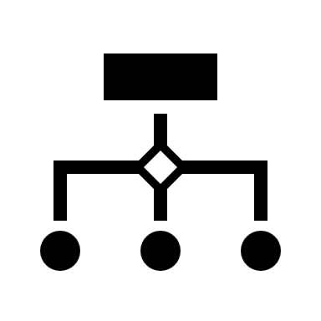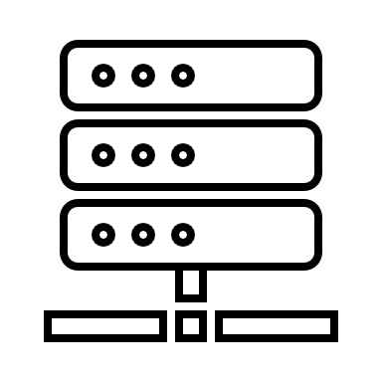

Application

Internet

Content Delivery Network (CDN)

Databases

Compute Instances

Figure 1. Core system design

The core system design for this patient risk profiling and care management project revolves around a user-centric approach, leveraging a central application server and potentially a content delivery network (CDN) for optimal performance and security.

The process begins with a user, such as a healthcare provider or patient, initiating an action within the system. This action could involve logging in, submitting patient data (symptoms, medical history), or requesting a specific service like risk profile generation. This user request is then routed across the internet and reaches the application server. This server, hosted either on a cloud platform or a local data center, is responsible for processing the request.

The application server acts as the brain of the system. Upon receiving a user request, it performs various tasks:

* **Database Interaction:** The server retrieves relevant patient information and medical records from a secure database. This data could include demographics, medical history, vital signs, lab results, risk assessment factors, and treatment protocols.
* **Risk Profile Generation:** Leveraging the retrieved data and pre-defined risk assessment algorithms, the server calculates and generates a patient risk profile. This profile summarizes the patient's susceptibility to specific health conditions.
* **Recommendations and Reports:** Based on the generated risk profile, the server can formulate recommendations for treatment or preventive measures. Additionally, it can create reports with visualizations to present the risk profile information clearly to the user.

Once the application server has processed the request and generated a response, it delivers this response back to the user through the internet. This response could be a comprehensive patient risk profile report, treatment recommendations, or access to relevant educational resources

Security is a top priority throughout this process. The system should be designed with robust security measures like data encryption, user authentication mechanisms, and authorization controls to restrict access to sensitive patient information based on user roles.

As the user base grows, the system needs to be scalable to accommodate the increased demand. This can be achieved by utilizing cloud-based resources that can automatically scale up or down based on real-time needs. Also, distributed computing techniques can be used to distribute the workload across multiple servers, ensuring optimal performance for many users.

The system should comply with relevant regulations such as HIPAA (Health Insurance Portability and Accountability Act) to ensure the protection of patient health information.

While not essential for all system designs, the inclusion of a CDN can enhance efficiency. The CDN stores and delivers frequently accessed static content like images and JavaScript files. This reduces the load on the application server, leading to faster response times for users.

2. Database Scaling

We plan on region-based scaling which will account for horizontal scaling and using vertical scaling in regions of high demand and population. It will use sharding and the content delivery system will use a hash table of the users to be able to identify which database has their data



Region 1

Low Traffic

Region 2

Low Traffic

Region 3

High Traffic

Figure 2. Database Scaling

3. Compute Scaling

The application and the machine learning models used within use a cloud-based computation system to keep the data separate from the computation and have additional flexibility and availability.

4. Machine Learning

The models are able to take in various inputs and through various Image-processing techniques such as the ones used in Chaturika et al. (2022) [22] and Convolutional neural networks to segment and detect abnormalities in the input scans and data. Firdaus et al. (2020) [13]

3.1.4 Technology Stack:

1. Mobile and Desktop App: Godot game engine
2. Website: Web framework (e.g., Django, React)
3. Backend Server: GCP or Firebase
4. Database: Google Cloud SQL or Firebase Realtime Database
5. Machine Learning: Google Colab
6. Computer Vision: TensorFlow, OpenCV
7. Programming Languages: Python, JavaScript (for website), GDScript (for Godot)

3.2 Working Principle

The fundamental aim of this application is to empower individuals in taking proactive control of their health while also contributing valuable data to the broader scope of community health research. Its operational framework integrates a straightforward yet robust strategy, intertwining user questionnaires with machine learning methodologies to generate bespoke risk profiles and furnish actionable insights.

Risk Profile Creation:

At its inception, the application prompts users to complete a comprehensive questionnaire encompassing various facets of their medical history, prevailing symptoms, and lifestyle habits. Subsequently, this information undergoes analysis by machine learning models, meticulously trained on an extensive repository of previously documented health profiles and diagnoses. Through this process, the models discern intricate patterns within the data and craft individualized risk profiles, delineating the likelihood of encountering different health conditions.

Simple Diagnostics and Recommendations:

Building upon the generated risk profiles, the application offers a concise diagnostic evaluation, elucidating potential health concerns and their corresponding probabilities. Presented in an intuitive and user-friendly manner, this information empowers users to make informed decisions regarding their health journey. Moreover, the application furnishes personalized recommendations, directing users towards seeking medical attention if their risk thresholds surpass predefined levels for specific conditions.

Data Aggregation and Health Trend Mapping:

Upon receiving a formal diagnosis or undergoing treatment, users have the provision to update their profiles within the application. This anonymized data is then amalgamated and subjected to analysis, culminating in the creation of dynamic health trend maps. These maps serve as invaluable tools, spotlighting prevalent health issues within the community and facilitating healthcare professionals and policymakers in identifying areas necessitating targeted interventions and resource allocations.

Local Storage:

A pivotal facet ensuring user privacy and data security is the application's utilization of local storage for housing risk profiles on individual devices. This decentralized approach obviates the need for storing sensitive health data on centralized servers, thereby mitigating the risks associated with potential data breaches. Additionally, the application seamlessly integrates with a plethora of Internet of Things (IoT) devices, such as wearable health trackers, which furnish real-time health data, thereby augmenting the accuracy of risk profiles and personalized recommendations.

Medical Professionals and Expedited Deductions:

Through its integration with IoT devices and local storage mechanisms, the application furnishes medical professionals with expedited access to pertinent health data, facilitating swifter deductions concerning patients' conditions. This streamlined approach not only facilitates earlier diagnoses but also engenders the formulation of more efficacious treatment plans, ultimately culminating in enhanced patient outcomes and overall healthcare efficacy.

Enhanced User Engagement and Empowerment:

Beyond its utility for healthcare professionals, this application serves as a catalyst for enhanced user engagement and empowerment in managing personal health journeys. By providing users with access to their risk profiles and personalized recommendations, the application fosters a sense of ownership and agency over one's health. Through interactive features such as progress tracking and goal setting, users are motivated to actively participate in their wellness endeavors. By empowering individuals to take charge of their well-being, the application catalyzes a shift towards a preventive healthcare paradigm, wherein early intervention and lifestyle modifications play pivotal roles in mitigating health risks and promoting overall wellness.

# 3.3 Results

The successful implementation of the application leads to significant positive impacts, including:

* Increased access to basic healthcare resources, especially in underserved communities.
* Improved early detection and prevention of health problems.
* Enhanced community awareness of health trends and risk factors.
* Empowering individuals to take control of their health and well-being.
* Providing valuable data for informed decision-making in local healthcare planning.

This project aims to contribute to a healthier and more resilient community by empowering individuals and creating a data-driven approach to community health management

The long-term impact of this project will be measured by observing changes in key health indicators within the community. These indicators could include a decrease in chronic disease prevalence, improved health literacy rates, and increased utilization of preventative health services. By empowering individuals and fostering a data-driven approach to community health, this project has laid the groundwork for a healthier and more resilient community for the future.

Comparing our method to previously prevalent methods

Table 1. Comparison with other methods

|  |  |  |
| --- | --- | --- |
| **Method** | **Description** | **Comparison** |
| Traditional Methods | Typically involves manual assessment by healthcare professionals based on patient history, symptoms, and diagnostic tools | * Relies heavily on the expertise of healthcare professionals, which can vary * Subject to human error and bias * Time consuming and resource intensive * Limited scalability * May lack consistency in diagnosis and risk assessment |
| Electronic Health Records | Utilize digital records of patient health information, including medical history, lab results, and treatment plans, to support clinical decision-making. | * Provides easy access to comprehensive patient data. * Still requires interpretation by healthcare professionals. * May lack real-time updates and integration with external data sources. * Limited in predictive capabilities without additional analytics tools. |
| Predictive Analysis | Uses statistical algorithms and machine learning models to analyze patient data and predict health outcomes, such as disease risk or hospital readmissions. | * Offers predictive capabilities based on historical patient data. * Can identify patterns and trends that may not be apparent to human assessors. * Requires large volumes of high-quality data for accurate predictions. * Needs ongoing validation and refinement to maintain accuracy. * May be challenging to interpret complex model outputs. |
| Wearable Health Devices | Monitor biometric data such as heart rate, activity levels, and sleep patterns continuously to track overall health and detect deviations from baseline. | * Provides real-time data. * Limited diagnostic capabilities. * Data accuracy and reliability vary. |
| Our Method | Utilizes machine learning models to analyze patient history, current symptoms, previous ailments, and lineage to assign a risk factor and provide diagnosis. Incorporates gamification principles for increased user engagement and proactive health management. | * Integrates various data sources for comprehensive risk assessment. * Employs machine learning for predictive diagnosis, potentially improving accuracy and efficiency. * Engages users through gamification, promoting proactive health behaviors. * Requires validation of ML models for clinical accuracy. * May face challenges in user adoption and data privacy concerns with gamification features. * Needs continuous updates and monitoring for algorithm performance and data quality. |

# 4.Discussion

The development of an application for patient risk profiling and care management represents a significant advancement in healthcare technology. By leveraging machine learning algorithms and utilizing a comprehensive dataset including user symptoms, previous ailments, and family history, this application has the potential to revolutionize how diseases and conditions are identified and diagnosed.

One of the key strengths of this project is its ability to provide personalized healthcare solutions. Traditional diagnostic methods often rely on generalized guidelines, which may not always accurately reflect an individual's unique health profile. However, by analyzing a patient's specific symptoms and medical history, this application can generate tailored risk profiles and treatment recommendations, enhancing the precision and efficacy of healthcare interventions.

Moreover, the integration of machine learning enables continuous improvement and refinement of the application's algorithms over time. As the system gathers more data and learns from user interactions, it can adapt and optimize its diagnostic capabilities, ultimately enhancing its accuracy and reliability.

Despite these strengths, there are several challenges and limitations that need to be addressed. One such challenge is ensuring the privacy and security of patient data. Given the sensitive nature of healthcare information, robust measures must be implemented to safeguard against unauthorized access and breaches.

Additionally, the effectiveness of the application may be influenced by factors such as data quality and diversity. Ensuring that the dataset is comprehensive and representative of diverse demographics will be critical to the application's success and generalizability across different populations.

# 5 Future Scope of this Work

Looking ahead, there are numerous avenues for further development and enhancement of this application. One potential direction is the incorporation of additional data sources, such as genomic data or wearable sensor data, to further refine the accuracy of risk profiling and diagnosis.

Furthermore, expanding the scope of the application to encompass preventive healthcare measures could have significant implications for public health. By proactively identifying individuals at risk for certain conditions and providing targeted interventions, such as lifestyle modifications or preventive medications, this application has the potential to reduce the burden of chronic diseases and improve overall population health outcomes.

Another promising area for future research is the integration of telemedicine capabilities into the application. By enabling remote consultations and monitoring, this could enhance accessibility to healthcare services, particularly for individuals in underserved or rural areas.

Moreover, ongoing research and development efforts should focus on enhancing the interpretability and transparency of the machine learning algorithms used in the application. Providing clinicians and patients with insights into how decisions are made can foster trust and facilitate collaboration in the healthcare decision-making process.

In conclusion, the development of an application for patient risk profiling and care management represents a significant step forward in leveraging technology to improve healthcare outcomes. By addressing challenges and embracing opportunities for further innovation, this application has the potential to transform the delivery of healthcare services and empower individuals to take proactive control of their health.

# 6 Individual Contribution

**Name:** Devansh Trivedi  
**Registration No:** 21BCE11407  
**Contribution:**

In our group project on patient risk profiling, I spearheaded the exploration of machine learning models for healthcare applications. This involved navigating the intricate world of machine learning algorithms and their potential within the healthcare domain. To gain a comprehensive understanding, I delved into a multitude of research papers, meticulously evaluating the latest advancements and methodologies in healthcare machine learning.

I thoroughly analysed various machine learning models and meticulously assessed each model's strengths, weaknesses, and suitability for different risk profiling scenarios. Key factors like performance metrics, interpretability, and scalability were under constant scrutiny. This in-depth evaluation allowed me to provide well-informed recommendations on selecting the most appropriate model for specific patient risk profiling tasks. Ultimately, my efforts ensured a scientifically rigorous and practically effective approach to patient risk profiling

**Name:** Yashsh Randive

**Registration No:** 21BCE11334

**Contribution:**

In the first phase of this project, I focused on establishing a strong foundation for patient risk assessment. I conducted thorough research on existing methodologies, algorithms, and relevant studies. By synthesizing insights from academic papers, I ensured our approach aligned with current best practices and scientific evidence. This research became the cornerstone for collaboration. I actively participated in discussions and brainstorming sessions, sharing findings and recommendations to foster continuous learning. Working closely with the team, I integrated these research findings into the project, facilitating the development of robust risk profiling mechanisms.

Next, I leveraged the research to refine and improve the risk assessment process. I actively participated in enhancing risk assessment protocols, ultimately improving the accuracy and effectiveness of patient risk profiling. This included supporting the team in implementing evidence-based strategies for risk assessment, promoting informed decision-making and patient safety. Finally, I played a key role in validating and refining the risk assessment models. Through data analysis and feedback from stakeholders, I assisted in ensuring the reliability and validity of the profiling system.

**Name:** Ankit Sankar  
**Registration No:** 21BCG10075

**Contribution**:  
In this project, I played a key role in transforming how healthcare professionals interact with medical imaging data. I leveraged cutting-edge data science tools and libraries in Python, like Matplotlib, Seaborn, and Plotly, to create insightful data visualizations. These visualizations, including bar graphs and confusion matrices, helped extract meaningful information from complex datasets, ultimately optimizing diagnostic processes and treatment planning.

Furthermore, I spearheaded the exciting integration of VR/AR technologies into the tool. I championed the development of both interactive VR environments and AR overlays. These advancements allowed healthcare professionals to visualize medical imaging data in a fully immersive 3D space, granting them a far more intuitive understanding of anatomical structures and pathological conditions.

**Name:** Rishikesh M

**Registration No.** 21BCG10072

**Contribution:**

My contributions to this project were multifaceted, encompassing a wide range of skills that significantly impacted the application's development and user experience.

First, I played a key role in crafting the application's visual identity. This included designing clear, intuitive, and aesthetically pleasing user interfaces (UI) that ensure users can easily navigate and interact with the application. Additionally, I may have created 3D models for VR environments or user interface elements, and developed artwork and visuals to enhance the application's overall look and feel.

Recognizing the importance of keeping users engaged, I spearheaded the implementation of gamification elements. This involved designing reward systems that incentivize healthy behaviours and motivate users to progress through the application's features. I may have also integrated progress bars and other visual cues that provide users with a sense of accomplishment as they interact with the application.

To ensure a smooth development process and future maintenance, I created comprehensive documentation for the application. This included user manuals and tutorials that guide users through the application's functionalities, and technical specifications and code documentation to support future developers working on the application.

I have also contributed to the development of the mobile application. This involved designing the mobile app's UI, developing functionalities specific to the mobile platform, and integrating the mobile app with the core application to ensure a seamless user experience across different devices.

In creating machine learning models, I have been involved in creating or integrating the model into the application. This included tasks like collecting data for training the model, training the model itself, and integrating the trained model with the application to leverage its capabilities.

Throughout the development process, I utilized my programming skills to develop essential functionalities within the application. This included writing code for data analysis and processing, implementing user interactions and logic for a smooth user experience, and building utility functions to optimize performance and maintainability.

By drawing upon these diverse skillsets, I was instrumental in the development of this project.

**Name:** Chetan Khoche  
**Registration No:** 21BCG10100

**Contribution:**

For this project, I played a key role in transforming the user experience (UX) and user interface (UI) of the platform. My mission was to make healthcare information not only accessible but also engaging and immersive for users. To achieve this, I leveraged a unique combination of technical expertise and design thinking.

At the core of my approach was a user-centric design philosophy. By employing human-centric design principles, I led the creation of intuitive interfaces that prioritized user needs and preferences. This meant meticulously considering user journeys and pain points to craft interfaces that were clear, effortless to navigate, and ultimately empowered users to find the information they needed quickly and efficiently**.** I also prototyped this design using front-end tools.

**Name**: GPV Mruthunjai

**Registration No:** 21BCE11559

**Contribution:**

In our project, I focused on developing a U-Net model for brain tumour segmentation, contributing to our team's efforts. With careful attention to detail, I worked on constructing a framework that utilized the U-Net architecture effectively. This involved thorough data preprocessing and parameter tuning to ensure optimal performance. Through iterative refinement and collaboration with team members, we achieved promising results in tumour localization from MRI scans.

**Name:** Rishabh Pradhaan  
**Registration No:** 21BCE11342  
**Contribution:**

I contributed to building, training, and testing the UNET based CNN Model that we are employing to Segment Brain Tumour. The model generates image masks brains with tumours.

**Name:** Siddharth Dayal  
**Registration No:** 21BCY10019

**Contribution:**

In the realm of healthcare management, I played a key role in harnessing the power of online data. My expertise in web scraping allowed me to extract vital information from government health databases and other official websites. This data encompassed crucial demographics, disease prevalence rates, symptom information, and updates on healthcare policies, all of which contributed to a real-time understanding of healthcare trends.

Beyond data extraction, I actively participated in the technical development of a user-friendly web application. This application, known as the Patient Health Status Identification and Care Management Tool, empowers healthcare professionals by allowing them to input patient data and leverage risk profiling algorithms. Furthermore, I spearheaded efforts to gather comprehensive health datasets from Kaggle, a renowned resource for data science projects. This comprehensive data pools further enriched the application's capabilities and aided in providing valuable insights for healthcare management.

**Name:** Ashutosh Kumar Srivastava

**Registration No.** 21BAC10005

**Contribution:**

As the lead member responsible for IoT (Internet of Things) in the "Patient Risk Profiling" project, I have been deeply involved in driving the integration of IoT technologies to enhance patient monitoring, risk assessment, and healthcare delivery. My role has encompassed a range of responsibilities and contributions aimed at leveraging IoT solutions to improve patient outcomes and optimize healthcare resources.

* This involved identifying suitable IoT devices, sensors, and connectivity solutions for data collection.
* Utilizing data analytics and predictive modelling to assess patient risk profiles.
* Assessing the short-term and long-term health impacts of the devices on the body that to be used.
* By leveraging advanced sensor technologies and data processing algorithms, the project aims to provide people with insights of their own health status and risk factors.
* the efforts are focused on harnessing the power of IoT data to enable proactive interventions and personalized healthcare strategies tailored to individual patient needs.

# 7. Conclusion

Despite initial challenges and the inherent complexity of the project, significant progress has been made in developing this innovative health application. The core backend infrastructure has been established, laying the foundation for further development and integration of key functionalities. Additionally, a foundational machine learning model capable of discerning specific health conditions has been successfully implemented, demonstrating the application's potential for personalized health assessment.

While substantial work remains to be done, the current progress provides a solid starting point for the project's next phase. Ongoing efforts will focus on expanding the application's functionalities, including the integration of additional health assessment tools, risk analysis models, and user-friendly interfaces. Additionally, collaborative efforts will continue to refine and improve the existing machine learning models and explore the integration of new algorithms for broader health diagnosis capabilities.

With continued dedication and focus, this project has the potential to revolutionize the way individuals manage their health and contribute to improved community well-being. The positive momentum established in the initial phase provides a foundation for continued progress and the development of a truly impactful mobile application for proactive health management.

# 8. References

1. Klasnja, P., Pratt, W., & Paasche-Orlow, M. K. (2017). Mobile health apps for promoting healthy behaviors: A systematic review and meta-analysis. *Journal of medical Internet research*, *19*(3), e83.
2. Mitesh, A., & Singh, S. K. (2019). Mobile health apps for early detection and prevention of non-communicable diseases: A narrative review. *Journal of Clinical and Diagnostic Research*, *13*(11), FE01-FE05.
3. Ventola, C. L. (2014). Mobile apps for the healthcare professional: Benefits, risks, and a framework for evaluation. *Pharmacy and Therapeutics*, *39*(4), 280-287.
4. Daniel Johnson, Sebastian Deterding, Kerri-Ann Kuhn, Aleksandra Staneva, Stoyan Stoyanov, Leanne Hides, Gamification for health and wellbeing: A systematic review of the literature, Internet Interventions, ISSN 2214-7829
5. Pereira, P., Duarte, E., Rebelo, F., Noriega, P. (2014). A Review of Gamification for Health-Related Contexts. In: Marcus, A. (eds) Design, User Experience, and Usability. User Experience Design for Diverse Interaction Platforms and Environments. DUXU 2014.
6. King D, Greaves F, Exeter C, Darzi A. ‘Gamification’: Influencing health behaviours with games. Journal of the Royal Society of Medicine. 2013;106(3):76-78
7. van Gaalen, A.E.J., Brouwer, J., Schönrock-Adema, J. et al. Gamification of health professions education: a systematic review. Adv in Health Sci Educ 26, 683–711 (2021).
8. Sean A. Munson, Erika Poole, Daniel B. Perry, Tamara Peyton, 2015. "Gamification and Health", The Gameful World: Approaches, Issues, Applications, Steffen P. Walz, Sebastian Deterding
9. Muangsrinoon, S.; Boonbrahm, P. Game elements from literature review of gamification in healthcare context. "JOTSE: Journal of Technology and Science Education", Febrer 2019, vol. 9, núm. 1, p. 20-31.
10. Lamyae Sardi, Ali Idri, José Luis Fernández-Alemán, A systematic review of gamification in e-Health,Journal of Biomedical Informatics,Volume 71,2017, Pages 31-48, ISSN 1532-0464.
11. Tracy MC, Okorie CUA, Foley EA, Moss RB: Allergic Bronchopulmonary Aspergillosis. Journal of fungi 2016, 2(2).
12. Huang, C., Leng, D., Li, L., Zheng, P., Sun, B., & Zhang, X. D. (2018). Transcriptome analysis of human peripheral blood reveals key circRNAs implicated in Allergic bronchopulmonary aspergillosis.
13. Firdaus Abdullah, M., Noraini Sulaiman, S., Khusairi Osman, M., Karim, N. K. A., Lutfi Shuaib, I., & Danial Irfan Alhamdu, M. (2020). Classification of Lung Cancer Stages from CT Scan Images Using Image Processing and k-Nearest Neighbours.
14. Riemann, D., Cwikowski, M., Turzer, S., Giese, T., Grallert, M., Schütte, W., & Seliger, B. (2018). Blood immune cell biomarkers in lung cancer.
15. Girard, N., Lou, E., Azzoli, C. G., Reddy, R., Robson, M., Harlan, M., … Pao, W. (2010). Analysis of Genetic Variants in Never-Smokers with Lung Cancer Facilitated by an Internet-Based Blood Collection Protocol: A Preliminary Report.Uu
16. Liu, B., Li, Y., Ghosh, S., Sun, Z., Ng, K., & Hu, J. (2019). Complication Risk Profiling in Diabetes Care: A Bayesian Multi-Task and Feature Relationship Learning Approach.
17. Shi, X., Hu, Y., Zhang, Y., Li, W., Hao, Y., Alelaiwi, A., … Shamim Hossain, M. (2016). Multiple Disease Risk Assessment with Uniform Model Based on Medical Clinical Notes.
18. N. Y. Philip, M. Razaak, J. Chang, S. M, M. O’Kane, and B. K. Pierscionek, "A Data Analytics Suite for Exploratory Predictive, and Visual Analysis of Type 2 Diabetes"
19. Grover, A., Kalani, A., & Dubey, S. K. (2020). Analytical Approach towards Prediction of Diseases Using Machine Learning Algorithms.
20. Rahman, T. M., Siddiqua, S., Rabby, S. E., Hasan, N., & Imam, M. H. (2019). Early Detection of Kidney Disease Using ECG Signals Through Machine Learning Based Modelling.
21. Shailaja, K., Seetharamulu, B., & Jabbar, M. A. (2018). Machine Learning in Healthcare: A Review.
22. Chathurika.K.B.A.B and Gamage. A., "Deep Learning Approach for Designing and Development of Risk Level Indicator for Patients with Lung Diseases," 2022 2nd International Conference on Advanced Research in Computing (ICARC), Belihuloya, Sri Lanka, 2022
23. Boonchieng, E., & Duangchaemkarn, K. (2016). Digital disease detection: Application of machine learning in community health informatics.
24. Roy, A. P., Chatterjee, S., Maji, P., & Mondal, H. K. (2020). Classification of ECG Signals for IoT-based Smart Healthcare Applications using WBAN.
25. Kaul, C., Kaul, A., & Verma, S. (2015). Comparitive study on healthcare prediction systems using big data.
26. Flynn, J. T., Mitsnefes, M., Pierce, C., Cole, S. R., Parekh, R. S., … Furth, S. L. (2008). Blood Pressure in Children with Chronic Kidney Disease: A Report from the chronic kidney disease in Children Study.
27. Malik, S., Kanwal, N., Asghar, M. N., Sadiq, M. A. A., Karamat, I., & Fleury, M. (2019). Data Driven Approach for Eye Disease Classification with Machine Learning.
28. Weiss, N., Miller, F., Cazaubon, S., & Couraud, P.-O. (2009). The blood-brain barrier in brain homeostasis and neurological diseases.
29. Park, D. J., Park, M. W., Lee, H., Kim, Y.-J., Kim, Y., & Park, Y. H. (2021). Development of machine learning model for diagnostic disease prediction based on laboratory tests.
30. Hiroki Kaneko, Hironobu Umakoshi, Masatoshi Ogata, Norio Wada (2021): Machine learning based models for prediction of subtype diagnosis of primary aldosteronism using blood test
31. Stevens, T., Rosenberg, R., Aird, W., Quertermous, T., Johnson, F. L., Garcia, J. G. N., … Garfinkel, S. (2001). NHLBI workshop report: endothelial cell phenotypes in heart, lung, and blood diseases.

# 9. Biodata

|  |  |
| --- | --- |
|  | |
| **Name:** | Devansh Trivedi |
| **Registration No:** | 21BCE11407 |
| **Branch:** | B. Tech in Computer Science Engineering |
| **Skills:** | Python Programming, Basic Machine Learning, Java Programming |
| **Bio:**  In my capacity as a researcher specializing in machine learning model selection, I have dedicated significant efforts to exploring various methodologies, algorithms, and empirical studies pertinent to predictive modelling in healthcare, particularly in patient risk assessment. With a steadfast commitment to excellence, I've meticulously synthesized insights gleaned from academic literature, refining our project's approach to model selection to align with the latest best practices and scientific evidence. My pivotal role extends to the validation and refinement of these models through rigorous data analysis and feedback mechanisms, ensuring that our chosen machine learning models are not only technically sound but also effective in addressing the complexities of patient risk assessment in real-world scenarios. | |
|  | |

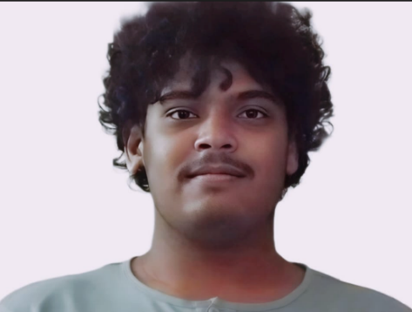

|  |  |
| --- | --- |
| **Name:** | GPV Mruthunjai |
| **Registration No:** | 21BCE11559 |
| **Branch:** | B. Tech in Computer Science Engineering |
| **Skills:** | Python, Machine Learning |
| **Bio:**  In our project, I played a key role in developing the U-Net model for brain tumour segmentation, contributing alongside my team members. With a focus on attention to detail, I worked on constructing a framework that utilized the U-Net architecture effectively. This involved thorough data preprocessing and parameter tuning to ensure optimal performance. | |
|  | |
| **Name:** | Rishabh Pradhaan |
| **Registration No:** | 21BCE11342 |
| **Branch:** | B. Tech in Computer Science Engineering |
| **Skills:** | Java, Python, SQL, CPP |
| **Bio:** | |
| I contributed to the ML aspect of the project. Training the model responsible for Brain Tumor Segmentation and connecting the model written in Python via Django to the backend of the site. This allows for patients to input their own data and receive an analysis from the model. | |
|  | |
| **Name:** | Yashsh Randive |
| **Registration No:** | 21BCE11334 |
| **Branch:** | B. Tech in Computer Science Engineering |
| **Skills:** | Java, Python programming |
| **Bio:** | |
| I've thoroughly researched various methods and studies on patient risk assessment, blending insights from academic papers to improve our project's approach. By analyzing data and gathering feedback, I've helped validate and fine-tune our risk assessment models to match current best practices and scientific evidence. | |

|  |  |
| --- | --- |
|  | |
| **Name:** | Rishikesh M |
| **Registration No:** | 21BCG10072 |
| **Branch:** | B. Tech in CSE with specialisation in Gaming technology |
| **Skills:** | Game Development, Game Design, Technical Art, and Tool Design |
| **Bio:** | |
| As the lead systems design and UI/UX designer for a project encompassing all aspects of user engagement, I designed the core systems, implemented gamification elements to drive user motivation, and oversaw the development of the mobile application. Additionally, I created a suite of utility and tool programs to streamline internal processes and enhance project efficiency. | |
|  | |
| **Name:** | Ankit Sankar |
| **Registration No:** | 21BCG10075 |
| **Branch:** | B. Tech in CSE with specialization in Gaming Technology |
| **Skills:** | Python Programming, C#, Front end Web Development, Unreal Engine, Unity Engine, Godot Engine |
| **Bio:** | |
| As a Virtual Reality (VR) Development Leader for a mobile health (mHealth) application running on the Godot engine, I spearheaded the creation of immersive and engaging VR experiences tailored for healthcare purposes. My expertise extended beyond VR, as I also contributed to the development of code for data visualization using Python and its libraries. Leveraging my skills, I implemented techniques such as bar graphs, confusion matrices, and outlier detection to provide healthcare professionals with intuitive tools for interpreting complex medical data. With a focus on innovation and user-centric design, I aimed to optimize the diagnostic and treatment planning processes for improved patient outcomes. | |

|  |  |  |
| --- | --- | --- |
|  | | |
| **Name:** | | Chetan Khoche |
| **Registration No:** | | 21BCG10100 |
| **Branch:** | | B.Tech in CSE with specialization in Gaming Technology |
| **Skills:** | | Game Development, Python Programming, UNITY Engine, Unreal Engine, Blender, C#, Web Development, Ethical Hacking |
| **Bio:** | | |
| As a Web Development Leader, I spearheaded the creation of immersive healthcare web experiences using HTML, CSS, and JS. With a dedication to user-centric design, my aim was to optimize health profiling and treatment planning for improved patient outcomes. Leveraging advanced JS techniques, I orchestrated seamless integration with backend datasets, facilitating robust data connectivity and analysis. | | |
|  | | | |
| **Name:** | Siddarth Dayal | | |
| **Registration No:** | 21BCY10019 | | |
| **Branch:** | B.Tech in CSE with specialization in Cybersecurity | | |
| **Skills:** | Python, C++, HTML, CSS, Java | | |
| **Bio:**  I have made significant contributions in extracting vital data from online sources for healthcare management. My expertise in web scraping has enabled the extraction of crucial data from government health databases and other official websites, including demographics, disease prevalence, symptoms, and healthcare policies, providing real-time information for decision-making processes. Additionally, I helped in developing a user-friendly web application, enabling healthcare professionals to input patient data and utilize risk profiling algorithms. Furthermore, I led efforts in gathering comprehensive health data from platforms like Kaggle, | | | |
|  | | | |
| **Name:** | Ashutosh Kumar Shrivastava | | |
| **Registration No:** | 21BAC10005 | | |
| **Branch:** | B.Tech in ECE | | |
| **Skills:** | Signal Processing, Networking Protocols, Embedded Systems, C++, Internet of Things | | |
| **Bio:** | | | |
| Possessing a background of electrical and communication engineering, I contributed to the real-time data accusation and communication establishment between the various parts of the system, among sensors, between database and sensors. Creating an infrastructure that can monitor the needed data from the sensors on the body and transfer it to the app/website for the necessary data analysis for the user profile. My expertise is also needed to make sure the devices used do not harm the health of the user in any way. | | | |